

WatchDog 3.4.8

Installation Document – I.C.E.

Version 1.2

Table of contents
1. About this document 3
about this document 3
revision history 3
related documents 3
2. Overview 4
general description of watchdog 4
3. Installation details 6
installation 6
responsible basset telecom solutions 6
ip addresses 6
passwords 6
watchdog client connection 6
system hardware 7
4. Dataflow at I.C.E. 8
overview 8
the filters 9
5. Applications and settings files 12
application files 12
settings files 12
6. Folder structures 14
server 1: wdapp 14
server 2: wddb 17
7. WatchDog client installation instructions 19
installation 19
8. Data backup 20
backup strategy 20
9. Support 21
support 21
system surveillance 21
error and unhandled folders 21
system maintenance 22

- About this document
about this document
This document describes the WatchDog installation at I.C.E. in Costa Rica.
revision history
Date | Version | Name | Comment
2005-09-09 | 1.0 | Patrik Stomberg | Creation of document
2005-09-12 | 1.1 | Patrik Stomberg | Completion based on final configuration
2005-09-23 | 1.2 | Patrik Stomberg | Added information about FileSQL that was added to solve punch list item concerning OME files
related documents
Document name | Description
WatchDog 3.4.8 – User Manual | Manual for the WatchDog analysis tools
WatchDog 3.4.8 – Admin Manual | Manual for the WatchDog system settings
WatchDog 3.4.8 – Database Description | Description of the WatchDog database
Decode32 – User Manual | Manual for the file handling platform
Abacus – User Manual | Manual for the rating application
- Overview
general description of watchdog
This section gives a general description of WatchDog. Please note that all information in this section may not be relevant for each specific installation.
This picture shows the different applications, the databases, and the information data flow for WatchDog.
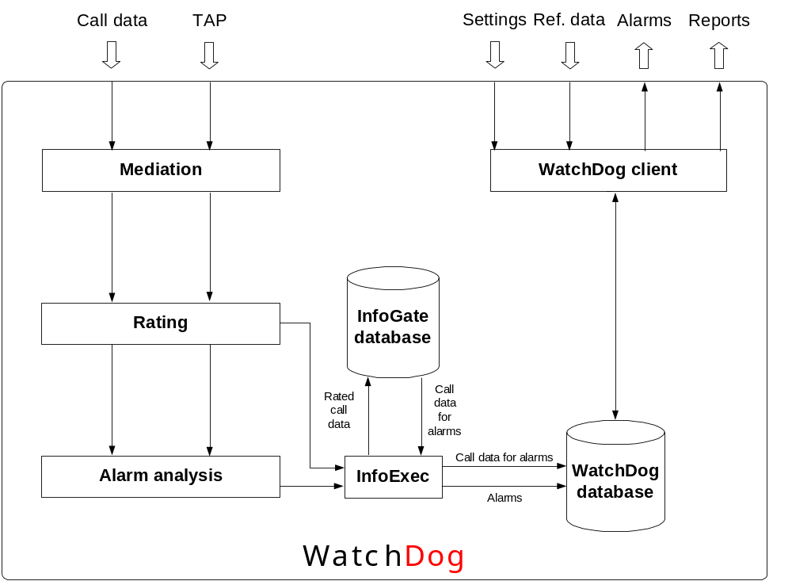
The databases
There are two databases in the system.
Database | Description
InfoGate | Call data for all subscribers. When alarms are generated, the corresponding call data is copied to the WatchDog database
WatchDog | System settings, alarms, call data that corresponds to existing alarms
The applications
The WatchDog system consists of the following applications.
Application | Description
Decode32 | Collection of raw data from switch, conversion, filtering, and modifications.
Abacus | Rating of call data.  Conversion of subscriber file.
Decode32Copy | Copy of rated files to alarms generator and for insertion into the database.
WatchDogAlarms | Alarms generation.
InfoExec | Insertion of alarm files into the database.  Insertion of rated call data files into the database.  Database cleaning.
FileSQL | Collection of OME files and insertion of the data into the database.
SQL Server | Database.
Input data
The WatchDog system can work with the following data.
Data | Description and source
Call data | Call data from the switch or mediation.
Roaming data | Call data from roaming partners (TAP files).
Subscriber data | Subscriber information from the billing system.
OME files | Call attempt data from the switch/EIR.
Prepaid account data | Prepaid account status data from the prepaid platform.
Prepaid call logs | Prepaid call information from the prepaid platform.
- Installation details
installation
Country | Company | Product
Costa Rica | I.C.E. | WatchDog 3.4.8
responsible basset telecom solutions
Name | Position | Contact details
Nicolaj Aaröe | Product manager | nicolaj.aaroe@basset.se
Christian Ledin | Project manager | christian.ledin@basset.se
ip addresses
Server | Name | Address | Domain
Application Server | WDAPP | 172.27.10.92 | N/A
Database Server | WDDB | 172.27.10.93 | N/A
passwords
Application server
Machine | User ID | Password
NT login on local machine | administrator | 123ice
Decode32 | basset | tessab
Abacus | basset | tessab
Decode32Copy | basset | tessab
WatchDogAlarms | basset | tessab
Database server
Machine | User ID | Password
NT login on local machine | administrator | 123ice
FTP to WDDB (Decode32Copy’s user to transfer CDRs to WDDB) | WatchDogFTP | WDftp123
WatchDog client administrator user | admin | tessab
watchdog client connection
Connection/Protocol | MS SQL Server 2000 ODBC (using TCP/IP)
Server | WDDB
Database | WatchDog
Type of access | Read, Write, Delete (SELECT, INSERT, UPDATE, and DELETE)
system hardware
Server 1 - Application server
Host Name | WDAPP
System Model | HP Proliant DL380
Server 2 - Database server
Host Name | WDDB
System Model | HP Proliant DL380

- Dataflow at I.C.E.
This section describes the system filters, i.e. the process flow for how the data is handled from raw data to alarms in the database.
overview
WatchDog in the I.C.E. network
The picture below illustrates how WatchDog is connected in the I.C.E. network.
Note! This picture is simplified.
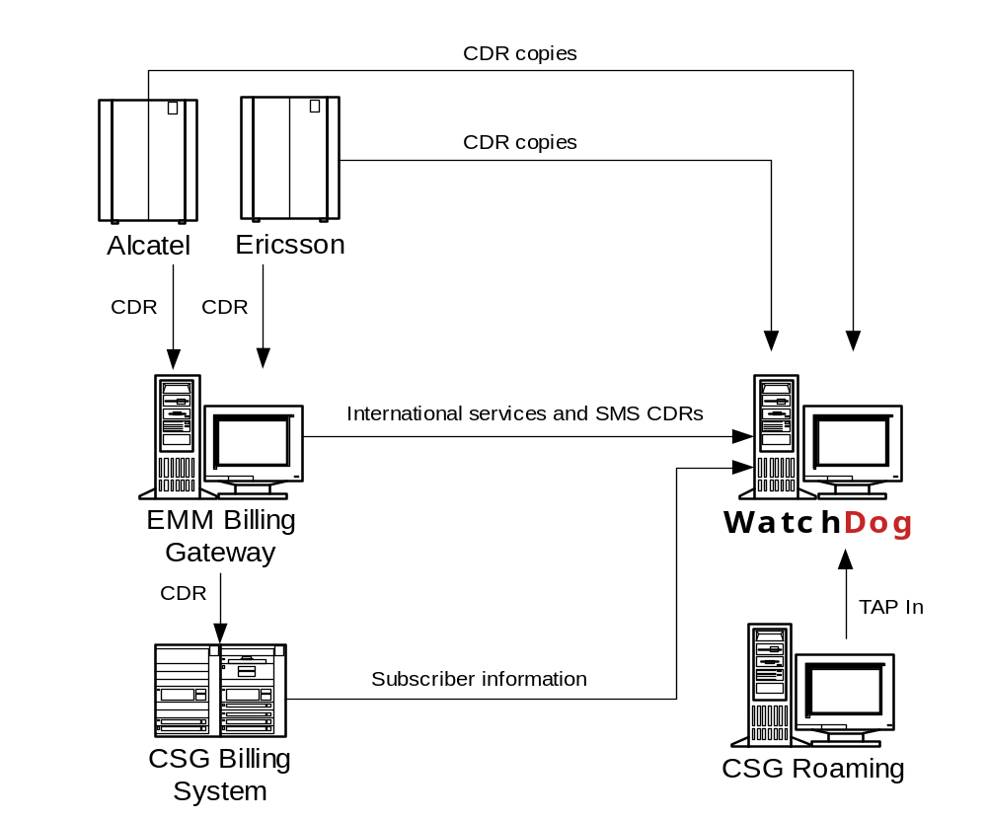
The WatchDog applications and dataflow
The picture below illustrates the applications and the dataflow on the WatchDog servers.
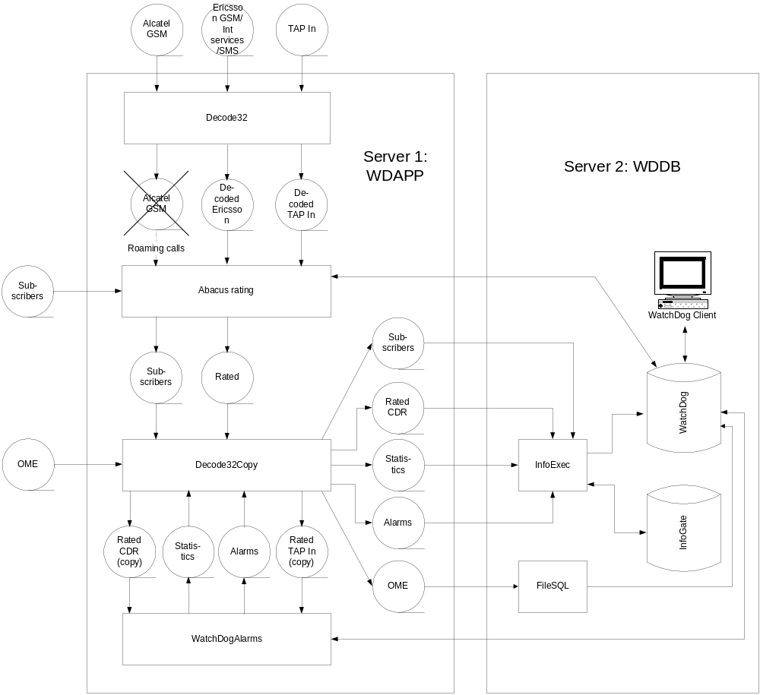
the filters
This section describes all process steps (filters) organised per application.
Decode32
Decode Ericsson R10
The Ericsson switches push the raw Ericsson files to the WatchDog server. This filter collects these files and decodes them to an internal format. This filter also skips unwanted records, makes number modifications and converts the cell ID values to hex format.
Convert to TAP2+
The TAP In files are pushed to the WatchDog server. This filter collects these files and converts them from the TAP 3.9 format to TAP2+.
Decode TAP2+
The converted TAP files are decoded to an internal format. Header and trailer records are removed.
Decode International Services
The mediation device pushes files with CDRs extracted from the Ericsson files, representing calls that have used certain services, to the WatchDog server. This filter collects these files and decodes them to an internal format. This filter also makes number modifications and matches the A number to the subscriber to retrieve the IMSI number. If no match is found for a record, it will be excluded from the process and instead be written to a file (E:\Basset\Data\1.Decode32\Output\Decoded\International Services\IMSIUnfound\*.raw).
Decode SMS
The mediation device pushes files with CDRs extracted from the Ericsson files, representing SMS calls, to the WatchDog server. This filter collects these files and decodes them to an internal format.
Decode Alcatel
The Alcatel switches push the raw Alcatel files to the WatchDog server. This filter collects these files and decodes them to an internal format. This filter also skips unwanted records, such as all records with IMSI number starting with 71201, and makes number modifications.
Abacus
Rate Ericsson R10
This filter rates the Ericsson R10 data.
Rate International Services
This filter rates the International Services data.
Rate SMS
This filter rates the SMS data.
Rate TAP
This filter rates the TAP In data.
Rate Alcatel
This filter rates the Alcatel data.
Fix Subscriber file
This filter converts the subscriber file provided by I.C.E to the format required by WatchDog. It also replaces the alphanumeric month values in the activation dates with numeric values, e.g. “JAN” is replaced with “01”.
Decode32Copy
Copy CDR to InfoExec
Copies the rated CDR file from Abacus to the InfoExec folder.
Copy CDR to WDA
Copies the rated CDR file from Abacus to WatchDogAlarms.
Transfer CDR to SQL DB
Transfers the rated CDR file from Abacus from the InfoExec folder to the database server.
Copy TAP to InfoExec
Copies the rated TAP file from Abacus to the InfoExec folder.
Copy TAP to WDA
Copies the rated TAP file from Abacus to WatchDogAlarms.
Transfer TAP to SQL DB
Transfers the rated TAP file from Abacus from the InfoExec folder to the database server.
Transfer Alarms to SQL DB
Transfers alarm and statistics files from WatchDogAlarms to the database server.
Transfer Subscriber file to DB
Transfers subscriber files from Abacus to the database server.
Transfer SiteList to DB
Transfers cell site lists to the database server.
Transfer OME file
Transfers OME files to FileSQL on the database server.
WatchDogAlarms
Generate alarms
Alarms generation.
Credit limit alarms
Credit limit alarms generation. This filter is triggered by a user action in the WatchDog client.
FileSQL
Import OME Records
Copies the rated CDR file from Abacus to the InfoExec folder.
- Applications and settings files
application files
The following application files are used for the WatchDog system. Please refer to the folder structure section regarding where these files are located.
Application Server
Application file | Version | Comment
Microsoft Windows Server | 2003 Enterprise Edition | Service pack 1
Decode32.exe | 1.98B296 | Decode32
Abacus.exe  ACConfig.exe | 1.98B339  2.0.0.245 | Decode32 renamed
Decode32Copy.exe | 1.98B280 | Decode32 renamed
WatchDogAlarms.exe | 1.99.0.149 | Decode32 renamed
InfoExec.exe | 1.0.2.1088
Gzip95.exe | N/A | Used to pack files that are backed up
PKZIP25.EXE | N/A | Used to pack files that are backed up

Database Server
Application file | Version | Comment
Microsoft Windows Server 2003 | Enterprise Edition | Service pack 1
Microsoft SQL server 2000 | 8.00.2039 | Service pack 4
InfoExec.exe | 1.0.2.1088
FileSQL.exe | 2.0.0.31
WatchDogClient.exe | 3.4.159
Smtpc.dll | 1.6.0.1099 | Mail function settings for InfoExec.exe
settings files
The following settings files are used for the WatchDog system. Please refer to the folder structure section regarding where these files are located.
Decode32
File | Comment
Decode32.ini | Settings for Decode32.exe
Alcatel.mod | Modifications settings for the Alcatel filter
International.mod | Modifications settings for the International Services filter
R10.MOD | Modifications settings for the >Ericsson R10 filter
TAP.mod | Modifications settings for the TAP filter
Abacus
Abacus.ini | Settings for Abacus.exe
ACCount.ini | System internal settings for Abacus.exe  This file is updated from ACConfig.exe
ACFlt001.ini | Rating settings for Abacus.exe – Ericsson R10  This file is updated from ACConfig.exe
ACFlt002.ini | Rating settings for Abacus.exe – International Services  This file is updated from ACConfig.exe
ACFlt003.ini | Rating settings for Abacus.exe – SMS  This file is updated from ACConfig.exe
ACFlt004.ini | Rating settings for Abacus.exe – TAP  This file is updated from ACConfig.exe
ACFlt005.ini | Rating settings for Abacus.exe – Alcatel  This file is updated from ACConfig.exe
ACFlt006.ini | Fix settings for Abacus.exe – Subscriber file  This file is updated from ACConfig.exe
ACGlobal.ini | Settings for Abacus.exe  This file is updated from ACConfig.exe
ACRatePl.ini | Settings for Abacus.exe  This file is updated from ACConfig.exe
MSCOMCT2.OCX | System file
MSCOMTL.OCX | System file
MSFLXGRD.OCX | System file
Decode32Copy
Decode32Copy.ini | Settings for Decode32Copy.exe
Decode2Copy.delta<n> | System file
WatchDogAlarms
WatchDogAlarms.ini | Settings for WatchDogAlarms.exe
WatchDogAlarms.wda | Settings for WatchDogAlarms.exe
InfoExec
Smtpc.dll | Mail function settings for InfoExec.exe
FileSQL
FileSQL.ini | Settings for FileSQL.exe
bcp.exe | Used by FileSQL to insert data into the database
bcp.dll | Used by FileSQL to insert data into the database
bcp.rll | Used by FileSQL to insert data into the database

- Folder structures
This chapter describes the folder structures where the applications and data are kept.
Note! All WatchDog installations are made in a similar manner. Hence some folders may not be relevant for each installation. In this section, such folders are commented as “Not in use”.
server 1: wdapp
Application folders
The application files are stored in the Basset folder on the E: Drive. They are organised as described below.
No actions should be taken to these folders.
Folder | Description
Apps
1. Decode32 | Application files and .ini files for the Decode32 application.
Backup | Safety backup of previous application and configuration files.
Buffer | Working storage.
Filters | Format configuration files for the International Services and SMS ASCII files.
ReportData | Log files for this application. A new file is created each day.
2. Abacus | Application files and .ini files for the Abacus application.
Backup | Safety backup of previous application and configuration files.
Buffer | Working storage.
ReportData | Log files for this application. A new file is created each day.
3. Decode32Copy | Application files and .ini files for the Decode32Copy application.
Backup | Safety backup of previous application and configuration files.
Buffer | Working storage.
ReportData | Log files for this application. A new file is created each day.
4. WatchDogAlarms
Backup | Safety backup of previous application and configuration files.
Buffer | Working storage.
ReportData | Log files for this application. A new file is created each day.
5. InfoExec | Not in use.
Logs | Not in use.
6. Client | WatchDog client installation file.
Data folders
The application files are stored in the Basset folder on the E: Drive. They are organised as described below.
Folder | Description | Comment
Data
1. Decode32
Backup | Backup of incoming raw data files.
<format> | There is one sub folder for each input format.
<date> | For each format folder a new sub folder is created for each day.
Input | Main folder for the system input data. | The input folders should contain only new files. Decode32 automatically cleans them.  Files that cannot be handled are renamed to *.err. If such files exist they should be analyzed.
Raw
<format> | There is one sub folder for each input format. The input files are pushed here by I.C.E.
Output | Main folder for the output data from Decode32. | The output folders should contain only new files. All files should be collected by the Abacus application.
Decoded | Main folder for decoded call data files. They are collected and deleted by Abacus.
<format> | There is one sub folder for each input format.
2. Abacus
Backup | Backup of incoming files.
<format> | There is one sub folder for each input format.
Error | Main folder for erroneous files from the rating. If Abacus cannot handle a file due to that it is corrupt it will be stored in these folders. | If files are found in these folders they should be analyzed.
<format> | There is one sub folder for each input format.
Output | Main folder for output files from Abacus.
Rated | Rated call data files. They are collected and deleted by Decode32Copy.
Unhandled | Main folder for records that fall through the rating process. | Check if files exist. That means that records fall through the rating, i.e. they are not covered by the rating configuration and will hence not be included in the alarms generation. Investigate why they are unhandled and take proper actions, such as adding parameters in Abacus.
<format> | There is one sub folder for each file format.
3. Decode32Copy
Error | Not in use.
Backup | Not in use.
4. WatchDogAlarms
Backup | Not in use.
Error | Not in use.
Input
Rated | Rated data for the alarms generation. They are placed here by Decode32Copy and deleted by WatchDogAlarms.
UsageStats | Working storage. It contains files only during the alarms generation process.
5. InfoExec
AlarmFiles | Alarm files created by WatchDogAlarms.
CDR | Rated CDR files from Abacus that should be transferred to the database server.
CellSiteList | If a file with a new cell site list should be imported to the system it should be placed here. Then it will be automatically inserted by the system.
Backup | Backup of processed cell site files.
EIR | OME files that should be inserted into the database should be put here. Then they will be automatically taken care of by the system. In the first step they will be converted.
SubscriberFile | Subscriber files that should be inserted into the database should be put here. Then they will be automatically taken care of by the system. In the first step they will be converted.
Backup | Backup of processed subscriber files.
TapIn | Rated TAP In files from Abacus that should be transferred to the database server.
Flat file alarms database folders
The WatchDogAlarms application stores data used for the alarms analyses in a flat file database. These files are stored in the Basset folder on the F: Drive. They are organised as described below.
Folder | Description | Comment
WDA DB | Flat file call data storage used for alarm analysis. | These files are updated by the system.
server 2: wddb
Application folders
The application files are stored in the Basset folder on the F: Drive. They are organised as described below.
No actions should be taken to these folders.
Folder | Description
Apps
InfoExec | InfoExec application and .ini files.
Logs | Log files for this application.
FileSQL | FileSQL application and .ini files.
ReportData | Log files for this application.
Data folders
The data files are stored in the Basset folder on the F: Drive. They are organised as described below.
Folder | Description | Administrator action
Data
5. InfoExec
AlarmFiles | Alarm files from WatchDogAlarms that should be inserted into the WatchDog database.
Done | If the database insertion is successful, the file is moved here.
Error | If the database insertion fails, the file is stored here. | Check this folder occasionally. If files exist, contact Basset.
AutoMail | If the system creates automatic e-mails the messages will be stored here until they are sent to the recipients.
Done | If the database insertion is successful, the file is moved here.
Error | If the database insertion fails, the file is stored here. | Check this folder occasionally. If files exist, contact Basset.
CDR | Rated call data files from Decode32Copy that should be inserted into the WatchDog database.
Done | Not in use.
Error | If the database insertion fails, the file is stored here. | Check this folder occasionally. If files exist, contact Basset.
EIR | OME files from Decode32Copy that should be inserted into the WatchDog database.
Done | If the database insertion is successful, the file is moved here.
Error | If the database insertion fails, the file is stored here. | Check this folder occasionally. If files exist, contact Basset.
RoamingReport | If the system creates automatic roaming reports they will be stored here until they are sent to the recipients.
Done | If the send is successful, the file is moved here.
Error | If the send fails, the file is stored here. | Check this folder occasionally. If files exist, contact Basset.
SiteList | Cell site list files from Decode32Copy that should be inserted into the WatchDog database.
Done | If the database insertion is successful, the file is moved here.
Error | If the database insertion fails, the file is stored here. | Check this folder occasionally. If files exist, contact Basset.
SubscriberFile | Subscriber files from Decode32Copy that should be inserted into the WatchDog database.
Done | If the database insertion is successful, the file is moved here.
Error | If the database insertion fails, the file is stored here. | Check this folder occasionally. If files exist, contact Basset.
TapIn | Rated TAP In files from Decode32Copy that should be inserted into the WatchDog database.
Done | Not in use.
Error | If the database insertion fails, the file is stored here. | Check this folder occasionally. If files exist, contact Basset.
Databases | Main folder for the WatchDog databases.
InfoGate | The InfoGate database.
Backup | Backups of the InfoGate database.
WatchDog | The WatchDog database.
Backup | Backups of the WatchDog database.

- WatchDog client installation instructions
installation
To install the WatchDog client, run the WatchDogInstaller installation program and enter the required information:
- Server name: 172.27.10.93
- Database name: WatchDog
The installation program performs the following:
- Copies required files
- Registers ActiveX controls
- Creates a WatchDog shortcut on the Start menu
- Creates a system DSN for WatchDog

- Data backup
backup strategy
The following data should be backed up:
WDAPP server
- E: drive (Application and data files)
- F: drive (Alarm analysis flat file database)
WDDB server
- F: drive (Application and data files, databases)
- Database backups under F:\Basset\Databases\InfoGate\Backup and F:\Basset\Databases\WatchDog\Backup

- Support
support
For system support, contact Basset Telecom Solutions as follows.
E-mail | watchdog.support@basset.se
Phone: Basset | +46 8 5626 7900
Phone: WatchDog Support | +46 8 5220 0391
Phone: Emergency WatchDog Support | +46 8 5220 0399
Fax | +46 8 28 62 31
system surveillance
The system administrator should perform the following routines on a regular basis to verify that the system is running properly.
Please also refer to the Decode32 – Surveillance Guide for general information about monitoring of Decode32 applications.
Applications
Check that the following applications/services are running.
Server 1
- Decode32
- Abacus
- Decode32Copy
- WatchDogAlarms
Server 2
- InfoExec
error and unhandled folders
Check the following data folders on the WDAPP server for error files and unhandled files.
Input files that could not be processed
- E:\Basset\Data\1.Decode32\Input\Raw\<format>\*.err
Records in International Services files with unknown phone numbers
- E:\Basset\Data\1.Decode32\Output\Decoded\InternationalServices\IMSIUnfound\*.*
Records that failed in the rating
- E:\Basset\Data\2.Abacus\Error\<format>\*.err
Records with values that are not configured in the rating
- E:\Basset\Data\2.Abacus\Unhandled\<format>\*.unh
system maintenance
The following settings may need to be updated (settings in the WatchDog client are not mentioned).
Rating
The system administrator may do the following changes.
Note! Do not make changes to the configuration if there are any doubts regarding what to do. The support agreement may not cover failures due to such actions. However, please do not hesitate to contact Basset for assistance.
Prices | Update price plans if prices are changing.
Prefixes | Add new number prefixes.
Schedules | Changes regarding the times for existing peak and off peak periods.
Exchange rates for TAP In
If the exchange rate between USD and SDR fluctuates, and this should be reflected in the charges for the TAP In data, the exchange rate needs to be updated in the system. This is done in the Decode32 application. Click Format Specific Settings (Edit Specific) in the Decode Tap2+ filter and go to the Rates/Offsets tab to change the exchange rate.
Subscriber data
The subscriber file should be sent to WatchDog on a regular basis. Please refer to the Folder Structure section for information about where the file should be placed.
Cell site information
New cell sites should be added in the client or the entire updated cell site list should be provided in a file. Please refer to the Folder Structure section for information about where the file should be placed.
Roaming partners and SDR exchange rate
Information about the roaming partners should be maintained in the client. This includes the exchange rate between SDR and USD.

